Parents, you do not have to expose your children to the public school’s Comprehensive Sexual Education.
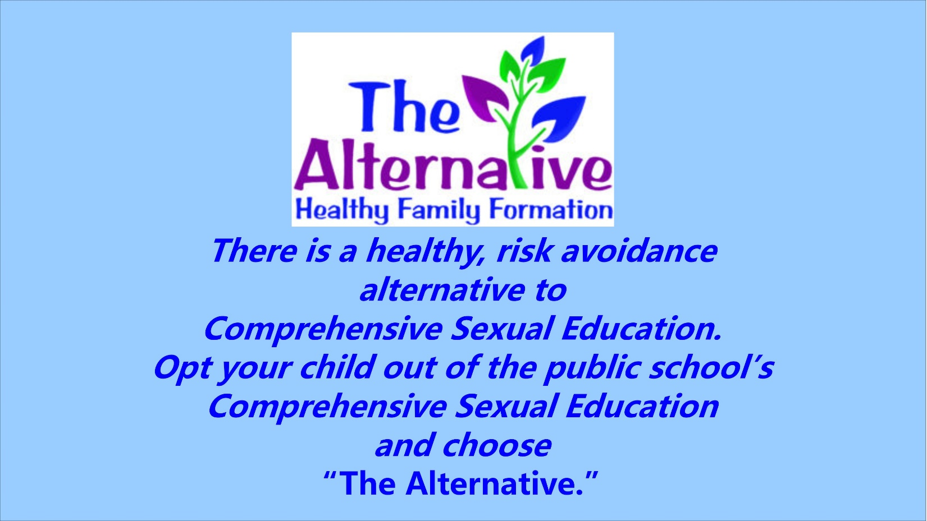

The Alternative is a state wide, federally authorized program

meant for teens grades 8-12 to attend with their parents.
The goal is to foster communication between
parent and child about reproduction, risk avoidance,

healthy relationships, and goal setting.
**************************************************************************************************************************
Sign up for this FREE 2-day parent and child workshop,
Friday, May 10th, 6-9 pm, &
Saturday, May 11th, 9 am-5 pm
Please bring your own lunch and snack on Saturday.
Church on the Rock
500 SW Eaton Blvd
Battle Ground
To sign up visit: betteralternative.weebly.com
Childcare WILL NOT be provided.
Please make arrangements for children not attending.
Sponsored by Citizens for Good Schools

